# 1. Executive summary

We believe KPMG is best positioned to help Technicolor achieve your objectives for the following reasons:

## Agility and flexibility

We ask, “Why not adopt the leading practice?” Our focus on innovation will not only help Technicolor implement leading HR practices, it also speeds up design and configuration and lets you focus on those decisions that truly make a difference to the organization.

Throughout the project, we’ll assess progress against your goals and seek ways to enhance efficiencies and further streamline our efforts, a truly agile approach to working. Working side-by-side with you, we’ll tackle challenges, find creative solutions, and create opportunities to achieve this goal.

## Beyond business as usual

Transformation is designed into our implementation approach. KPMG invests more than $5 million each year in our Powered Enterprise delivery framework, our leading practices database, and methodology. We supplement primary research with our own experience working across platforms and industries to identify leading practices and build them into our implementation process. We deliver the results that matter—simple, aligned, measurable, scalable, and demonstrable—with immediate and long-term financial benefits.

## A team you can trust

Due to current COVID-19 restrictions, Technicolor will experience some of the KPMG consultants working remotely with your team. We have shifted to completely virtual delivery on several large-scale, in-flight Workday projects across multiple industries and geographies, and these projects are progressing according to planned timelines. We have the tools and experience to effectively work with Technicolor and are fully prepared to begin this work virtually. In addition to our Workday implementation experience, we also bring extensive HR Transformation, project management, training, security and controls, and change management experience and our team is trained in industry standard approaches and leading practices for Workday delivery as it relates to these areas. We can provide longer-term help desk/application support and continuous improvement skills and capabilities you require to support this initiative, from start to finish. KPMG has repeatedly successfully delivered successful programs like this. Our proposed team organization chart for the Technicolor project follows. Please see **Appendix F** for representative resumes.

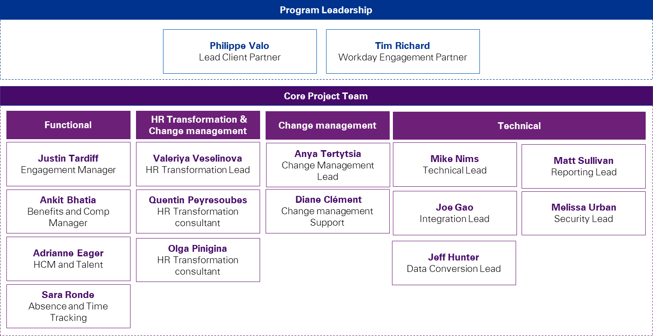

## True collaboration

Successful execution of programs of this magnitude and impact requires attention to the unique attributes of the organization, its values, and its people. All too often advisors take a templated and scripted approach, employing a “we’ve done it before, we know what you need” mantra. While KPMG will use our vast Workday and people transformation knowledge to deliver a world-class program, the way *you* work with us will be unique and we’ll prioritize that. We’ll take a highly collaborative approach to achieve Technicolor’s desired outcomes.

## KPMG’s strength in Workday-led HR transformation

Technicolor will benefit from our deep knowledge and expertise in Workday technology. We’re leaders in Workday implementation and transformation and the world’s leading companies turn to KPMG for their Workday-enabled transformation needs.

We’ve been implementing Workday since Release 2, and built our project knowledge, research, and experience into our Powered Enterprise integrated methodology. Powered Enterprise will provide you with an accelerated starting point to design your Workday environment with operations, business processes, automation, adoption, and change in mind.

Our Workday business has grown rapidly during the last 12 years and our KPMG team is our biggest differentiator. Team members understand the high-impact decisions Technicolor must make, and you’ll receive our experience and knowledge to help ensure decisions align to your business goals. This means:

* Nothing goes live unless it’s RIGHT for Technicolor and enhances the overall employee experience. We’ll help you to do the RIGHT work in the RIGHT place for the RIGHT people.
* We’re your partner. We’re here to listen and learn as well as provide leading practices and a proven approach for your Workday-enabled transformation. We’ll also challenge the old ways of working and bring you innovative thinking.
* You’ll receive the best team who bring relevant industry knowledge, Workday experience, and a deep understanding of the human resources function and its business touchpoints.

